**Distribution of medical facilities in the US and their quality**

**Group Members:** James Bruning, Sabyasachi Das, Nick Kelly

**Project Goal**

The goal of our project was to explore the relationship between the number of healthcare facilities available at the state and local level in America and factors such as population, median income, quality of care, and health outcomes.

**Motivation**

Lack of access to adequate healthcare is a problem that affects millions of Americans. Many Americans live in what are called “care deserts” or “medical deserts,” areas where proper healthcare facilities are scarce. This problem is especially pronounced in rural areas where, according to the American Hospital Association, fewer than 10% of doctors work despite rural America housing 20% of her total population. If a large number of Americans live in care deserts, exploring the relationship between lack of healthcare facilities and other factors - such as median family income and average life expectancy - might yield useful information for policymakers.

**Q1. How are different medical facilities like hospitals, home healthcare agencies (HHCs) and pharmacies distributed in the United States?**

For hospitals, Texas has the most hospitals, followed by California. Most of the US territories like Virgin Islands, Guam, Northern Mariana Islands and American Samoa have the least. The state with the least number of hospitals is Delaware.

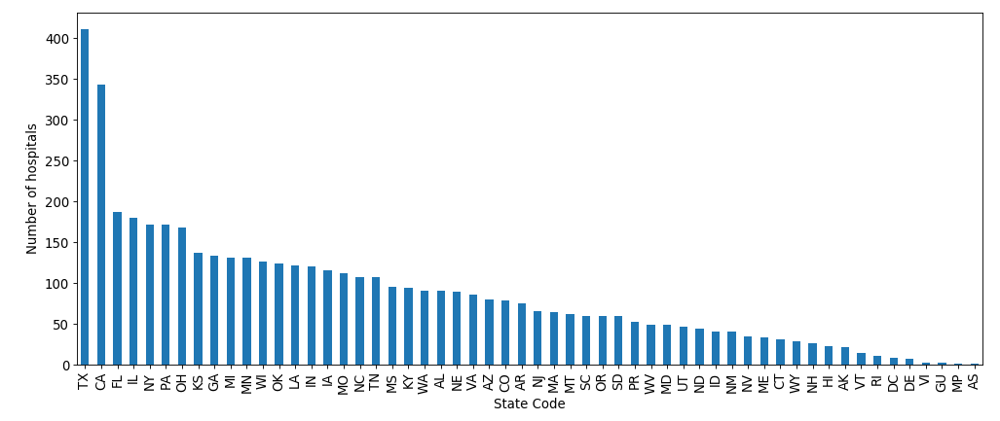

The red dots in the following map of the contiguous states of the US depicts a better distribution of the hospitals.

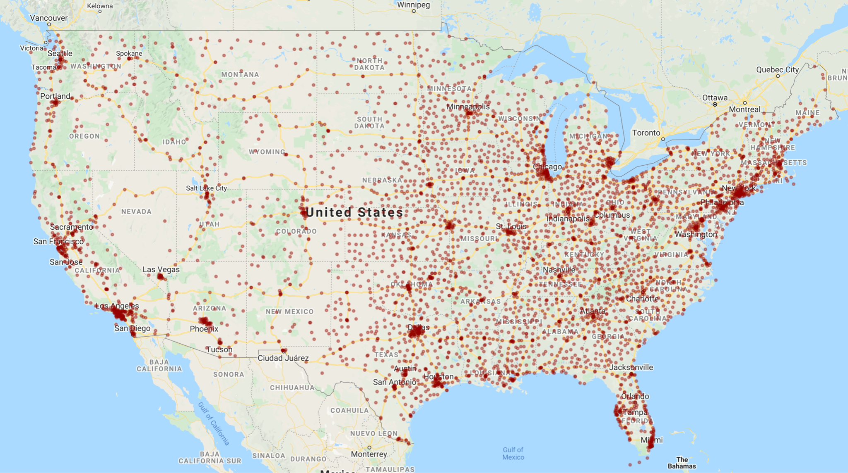

For home health care agencies, the large majority are located within Texas, California, Florida, Ohio, and Illinois rounding out the top 5. The distribution is very top heavy with the top 10 states containing almost 70% of the facilities.

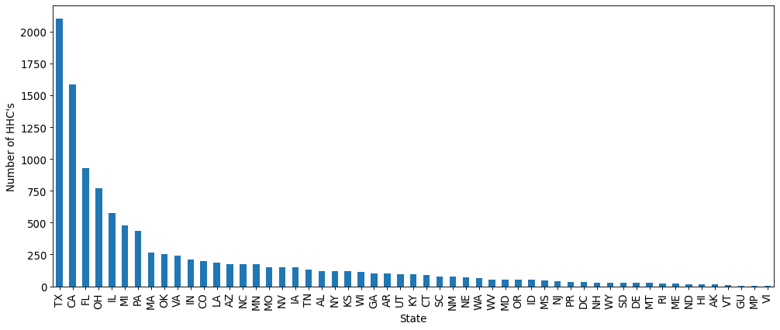

**Q2. What is the quality rating of these medical facilities?**

For hospitals, the average overall quality of hospitals in each state was calculated by assigning scores of 1 (better than national average), 0 (equal to national average) or -1 (worse than national average) for seven quality parameters (mortality, safety of care, readmission, patient experience, effectiveness of care, timeliness of care and efficient use of medical imaging) to each hospital and then calculating a total score for each hospital (which was averaged over each state). Texas has the most number of hospitals with quality better than the national average. California had the most hospitals with quality worse than the national average.

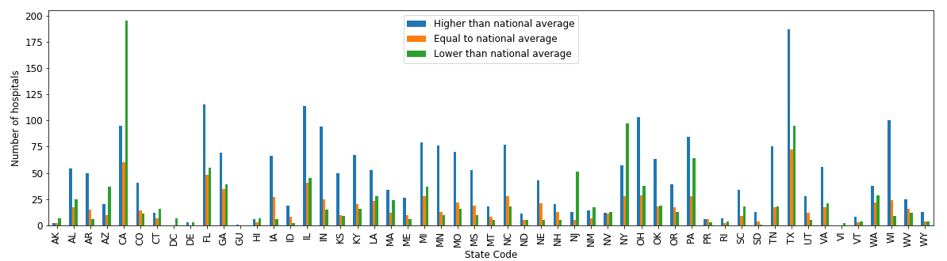

For home health care the quality and satisfactory ratings were based largely on an overall quality of care patient rating that the hospital used as an aggregate based on multiple questions put into a scale of 1-100. This aggregate was then broken down into a 1-5 star rating. A breakdown is shown based on state focused grouping

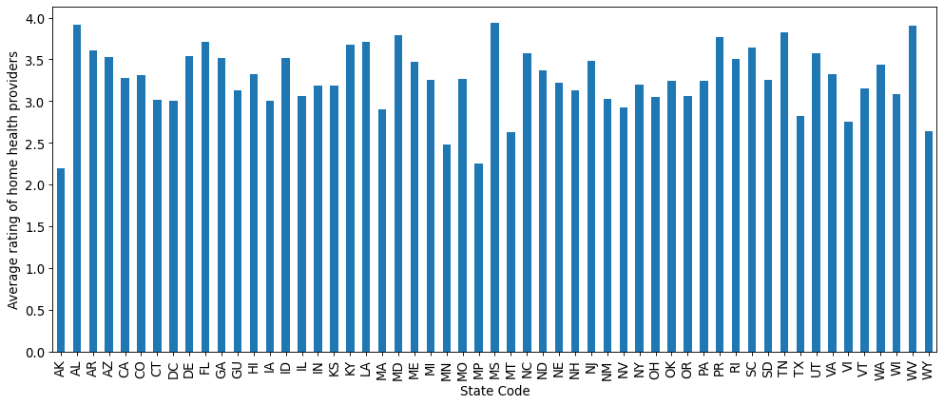

**Q3. How can these medical facilities be sub-classified based on their ownership and/or services they provide?**

For hospitals, classification may be done on type of ownership or type of hospitals. Based on ownership type, most are voluntary, non-profit and private followed by proprietary hospitals. Detailed classification by ownership can be found in the stacked bar plot below.

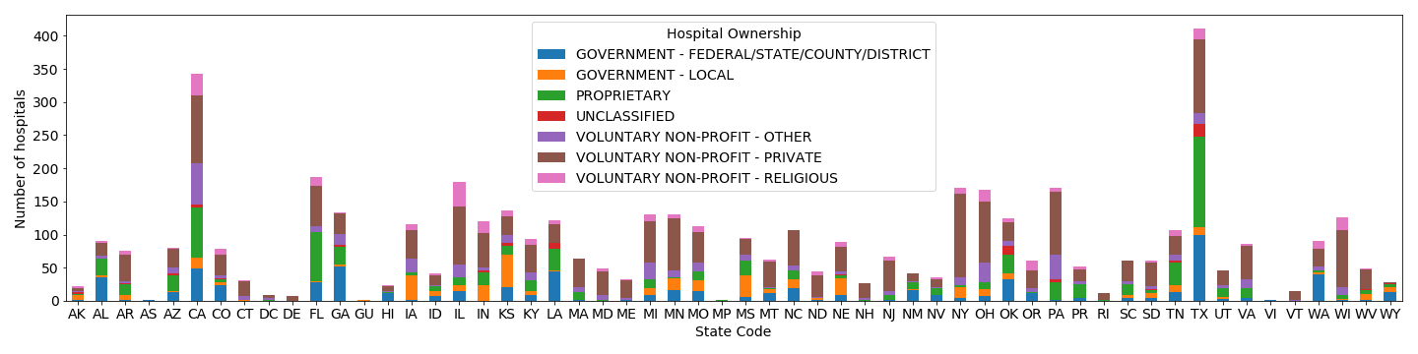

Based on type of hospital, most hospitals are acute care hospitals, followed by critical access hospitals. Children’s hospitals are least in number.

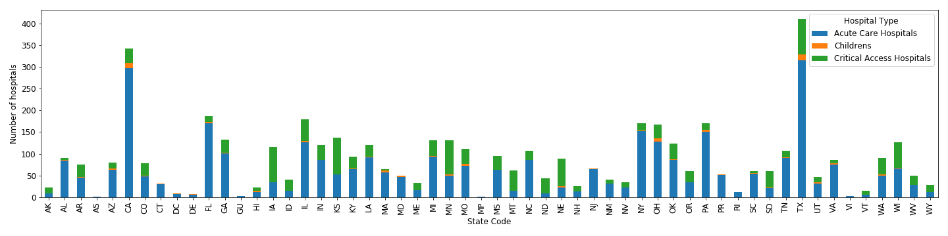

For home healthcare the break down was very heavily weighted towards “Proprietary” and then only a steady helping of other contributors shown in the graph below.

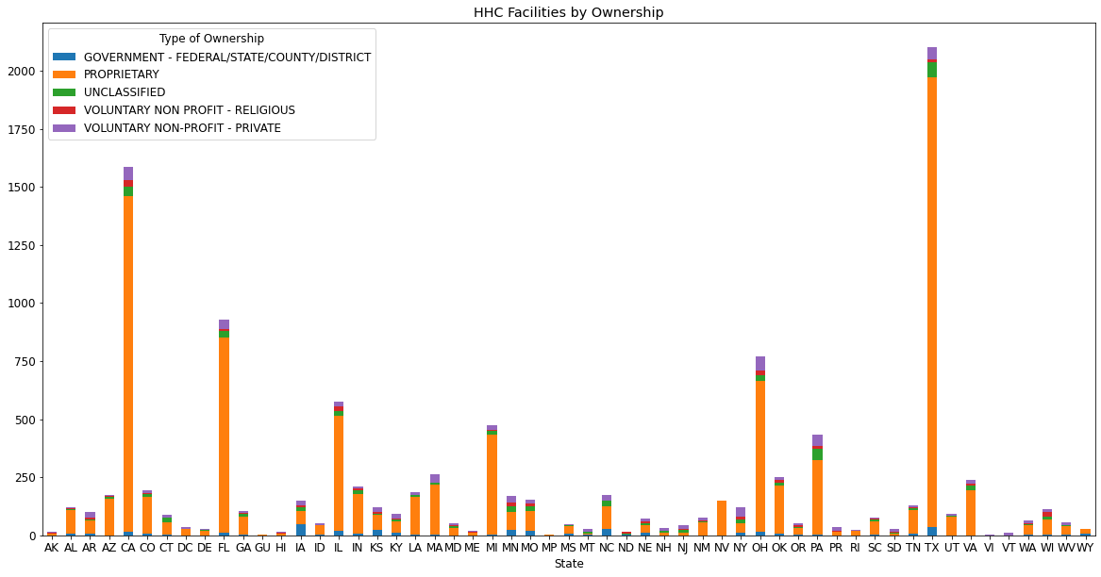

**Q4. Is there any correlation between the number of these different types of medical facilities and factors like population and median household income?**

For hospitals, when the number of hospitals has no correlation (R-squared value of 0.05) with the median income in the region.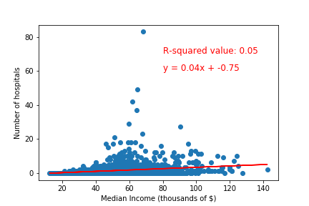

The following heat map depicts a more detailed picture.

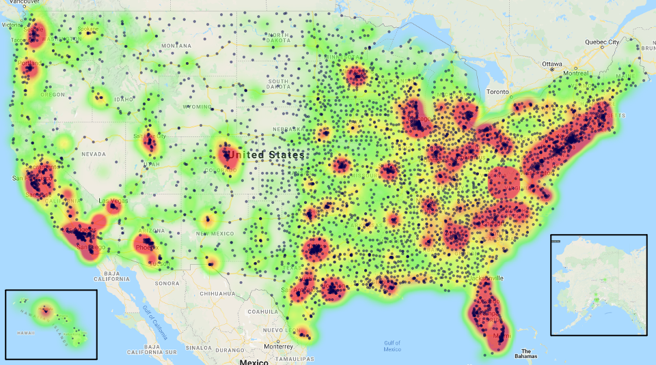

For hospitals, The number of hospitals in a region was directly related to the population of the region (R-squared value of 0.84)

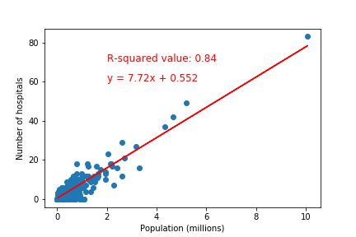

The following heat map depicts a more detailed picture.



For pharmacies, the number of locations had no significant correlation with median household income (R-Squared = 0.0708).

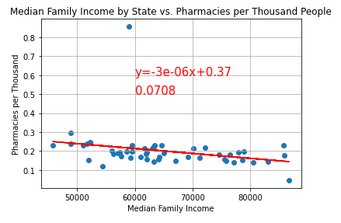

The same was true for free clinics against median household income (R-Squared = 0.0067)

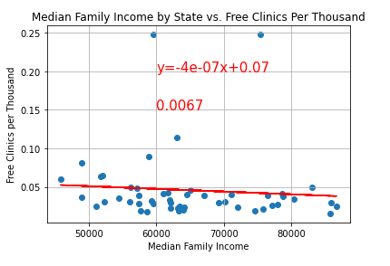

In addition, no strong correlation was found between life expectancy and the number of pharmacies per thousand people.

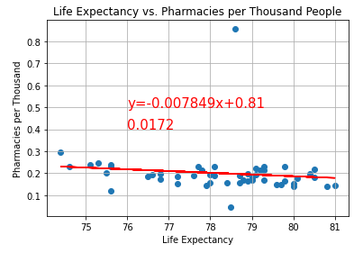

A similar result can be found for the relationship between life expectancy and the number of free clinics per thousand people, with no strong correlation.

